2022

Student Name

Student ID

Website Production

Table of Contents

Introduction 1

Audience and Purpose 1

Overview 1

Assets 1

Primary 1

Secondary 1

Sources table 1

Editing 1

Images 1

Text 1

Video 1

Justification 2

Planning 2

File structure 2

Wireframes 2

Moodboard 2

Production Log 2

Website creation 2

Overview Screenshots 2

Test Table 2

# 

# Introduction

## Overview

Client brief:

## Audience and Purpose:

## The target audience of this site are people in their young adulthood (18-25), due to the site’s content of reviews of games which are of the age of 18+. Assets

## Primary

* *All images you have taken*
* *All text you have written*

## Secondary

* *All images you have sourced*
* *All text you have sourced*

## Sources table

|  |  |  |  |  |
| --- | --- | --- | --- | --- |
| Asset Number | Asset Type | Asset | Source | File Name |
| 001 | PNG |  | Creator Name: Naughty Dog  Year Published: 2022  Title of Image: ‘The Last of Us Part 1’  URL: <https://www.playstation.com/en-gb/games/the-last-of-us-part-i/> | ‘Background.png’ |
| 002 | PNG |  | Creator Name: Naughty Dog / Sony Interactive Entertainment  Year Published: 2022  Title of Image: ‘The Last of Us Part 1’  URL: <https://www.amazon.co.uk/Last-Us-Part-I/dp/B0B4D7STV7/ref=asc_df_B0B4D7STV7/?tag=googshopuk-21&linkCode=df0&hvadid=606618056061&hvpos=&hvnetw=g&hvrand=14314617410958674997&hvpone=&hvptwo=&hvqmt=&hvdev=c&hvdvcmdl=&hvlocint=&hvlocphy=9046757&hvtargid=pla-1679233358829&th=1> | ‘PS5Tlou.png’ |
| 003 | PNG |  | Creator Name: Naughty Dog  Year Published: 2022  Title of Image: ‘The Last of Us Part 1 Logo’  URL:  <https://www.google.com/search?q=the+last+of+us+part+1+logo&oq=the+last+of+us+part+1+logo&aqs=chrome..69i57j0i512j0i390l5.6737j0j15&sourceid=chrome&ie=UTF-8#imgrc=9m5RSDqqUR7NkM> | ‘The Last of Us Logo – Edited.png’ |
| 004 | PNG |  | Creator Name: Naughty Dog / Sony Interactive Entertainment  Year Published: 2022  Title of Image: ‘The Last of Us Part 1’  URL:  <https://www.google.com/search?q=the+last+of+us+part+1+pc&tbm=isch&sxsrf=ALiCzsanDx_-rlQv_UxeUOj0BoZVgtgYtQ:1671803524345&source=lnms&sa=X&ved=2ahUKEwj_p8-58Y_8AhUimVwKHcFlDYoQ_AUoBHoECAEQBg&biw=669&bih=689&dpr=2#imgrc=6-OzT-Un3LRgPM> | ‘TheLastOfUsPC.png’ |
| 005 | PNG |  | Creator Name: Jack Petty  Year Published: 2022 |  |
| 006 | PNG |  | Creator Name: Naughty Dog / Sony Interactive Entertainment  Year Published: 2022  Title of Image: ‘The Last of Us Part 1’  URL:   1. <https://www.playstation.com/en-gb/games/the-last-of-us-part-i/> 2. <https://www.amazon.co.uk/Last-Us-Part-I/dp/B0B4D7STV7/ref=asc_df_B0B4D7STV7/?tag=googshopuk-21&linkCode=df0&hvadid=606618056061&hvpos=&hvnetw=g&hvrand=14314617410958674997&hvpone=&hvptwo=&hvqmt=&hvdev=c&hvdvcmdl=&hvlocint=&hvlocphy=9046757&hvtargid=pla-1679233358829&th=1> | ‘TLOUPs5.png’ |
| 007 | PNG |  | Creator Name: ShutterStock  Year Published: N.D  Title of Image: ‘The Last of Us Part 1’  URL:  <https://www.google.com/search?q=tech+company+banner+stock&tbm=isch&ved=2ahUKEwjE3-KM_o_8AhVEmicCHUeCBEsQ2-cCegQIABAA&oq=tech+company+banner+stock&gs_lcp=CgNpbWcQAzoECCMQJzoGCAAQCBAeOgcIABCABBAYOgUIABCABDoGCAAQBRAeOgQIABAeUABYoCRgpyZoAHAAeACAAT-IAY8IkgECMTiYAQCgAQGqAQtnd3Mtd2l6LWltZ8ABAQ&sclient=img&ei=x7-lY4TgOcS0nsEPx4SS2AQ&bih=789&biw=1440#imgrc=pMtt7FWnV47KDM&imgdii=WzhT7wFnWgpSuM> | ‘AboutBanner.png’ |
| 008 | PNG |  | Creator Name: Boot Strap  Year Published: N.D  Title of Image: ‘Twitter Icon’  URL:  <https://icons.getbootstrap.com/icons/twitter/> | ‘Twitter.png’ |
| 009 | MP4 |  | Creator: Jack Petty  Year Published: 2022  Title of Asset: The Last of us Review  <https://www.youtube.com/watch?v=NuX8SwpSdLU> | ‘The Last of us Review.mp4’ |

# Editing

## Images

* All images you have edited (before and after evidence)
* Explanation of editing technique used
* All graphics you have created (icons, logos, anything)

## Text

* All text you have edited (before and after evidence)

|  |  |  |
| --- | --- | --- |
| Asset Number | Asset Type | Manipulation |
| 1 | Secondary | Saturation, turned down.  Filter applied to image. |
| 2 | Secondary | Background removed.  Shadow applied. |
| 3 | Secondary | Colour changed.  ‘Part 1’ text centred. |
| 4 | Secondary | Shadows increased. |
| 5 | Primary | Creation of the image (movement of shapes). |
| 6 | Secondary | ‘Background’ image taken and combined with ‘PS5Tlou’ image and the second image has been placed on the left hand side. |
| 7 | Secondary | Colour changed to green.  Image Cropped. |

# Justification

* Fully justify text selection in terms of audience and purpose (Primary + Secondary)
* Full justify image choice in terms of audience and purpose (Primary + Secondary)

We made the decision to use ‘Lorem Ipsum’ and placeholder text on our site. This way the text can easily be changed by the clients.

In the About page, I choose to make the banner along the top green, to ensure that the asset bended in with the site’s overall colour scheme of white, black and green.

The logo was also produced with the site’s overall colour scheme in mind. The logo is also very simple yet eye catching, therefore it is appealing to audiences.

The rest of the images for the site were chosen with the game review on the page in mind. They are simplistic but they also present the game well and make it appealing to audiences and the client.

# Planning

## File structure

* Explanation of the importance of file structure

File structure is important in website production as it makes it easier for clients to navigate the site you have made when you send it to them.

* Screenshot evidence of good file structure with explanation

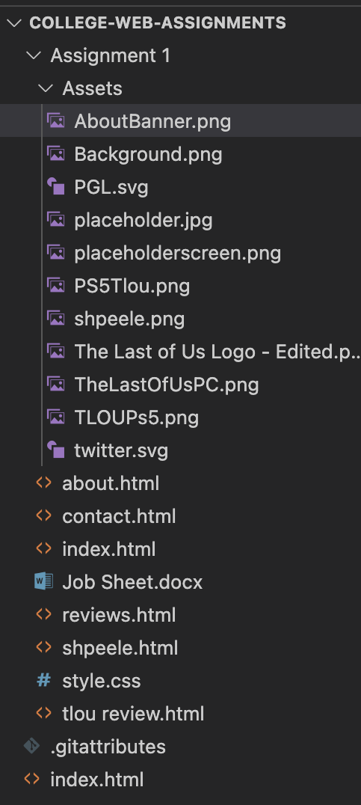

When creating our website, we ensured to put all our assets in an asset folder, so the code was easy to navigate, and assets were easier to locate, and the code was easier to locate as it was in a separate file from the assets

## Wireframes

Home Page:

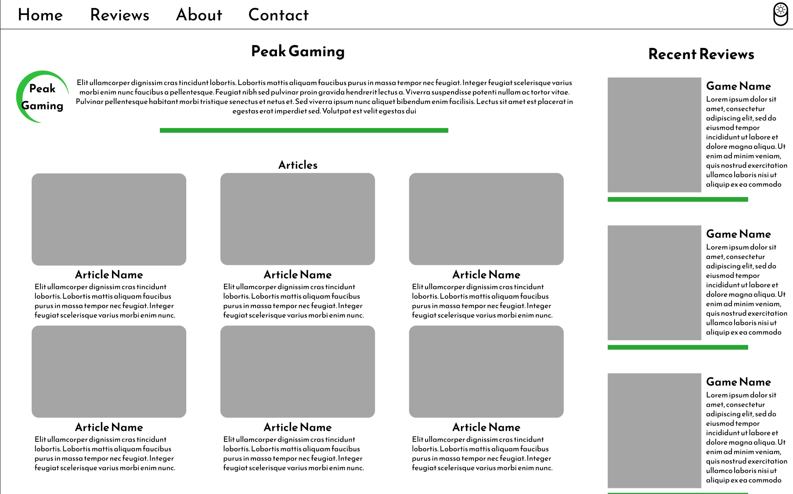

About:

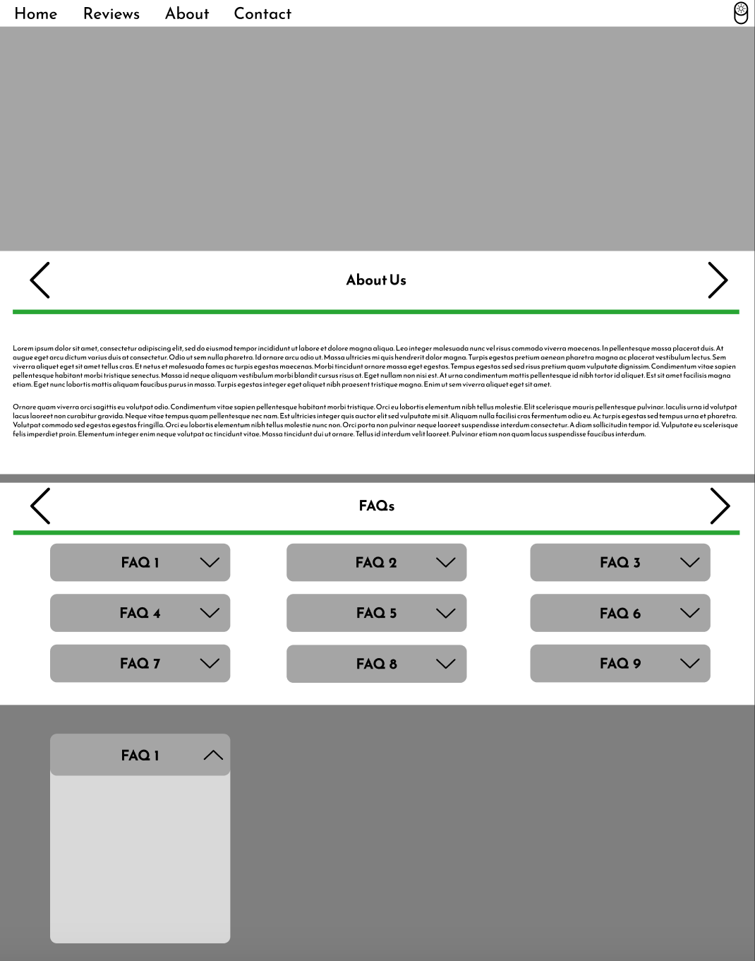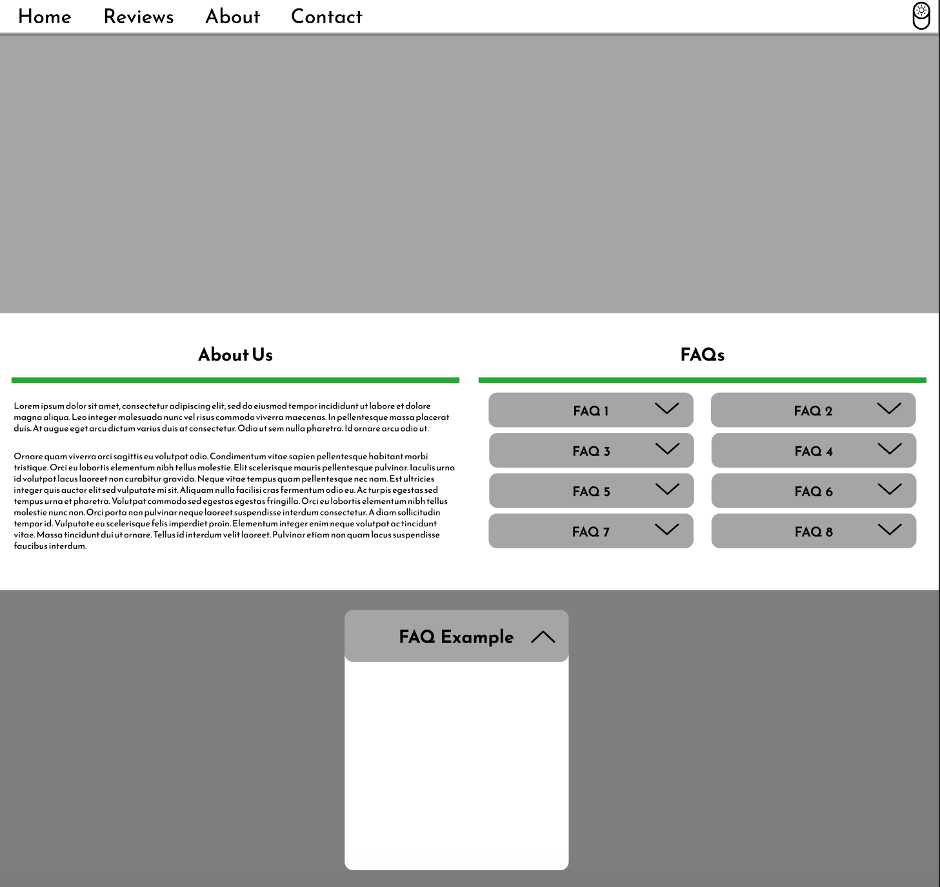

Reviews page:

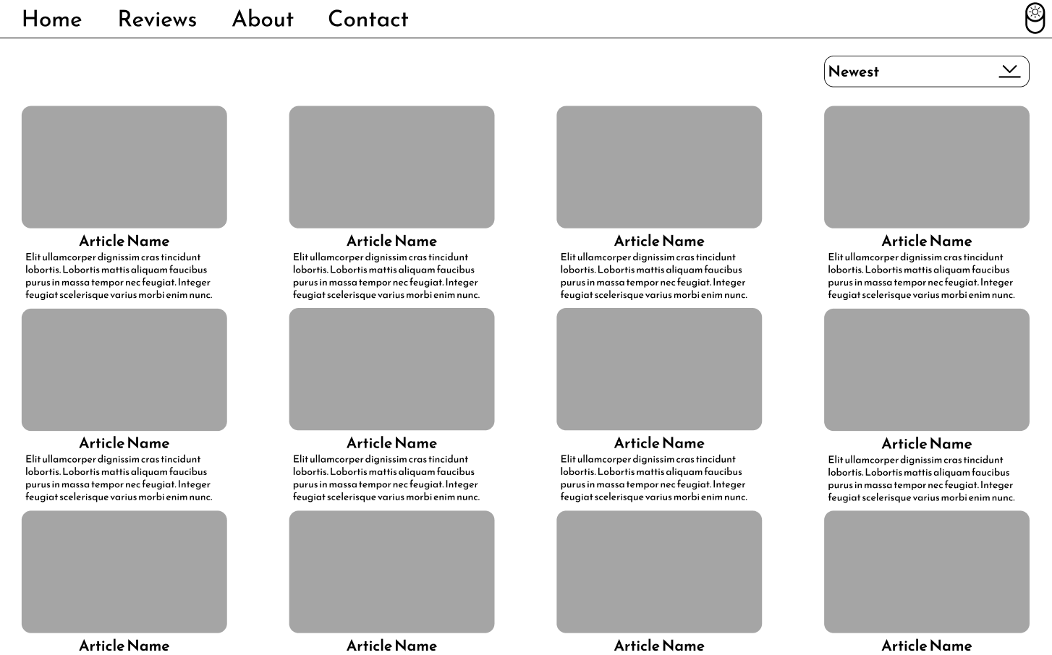

Contact:

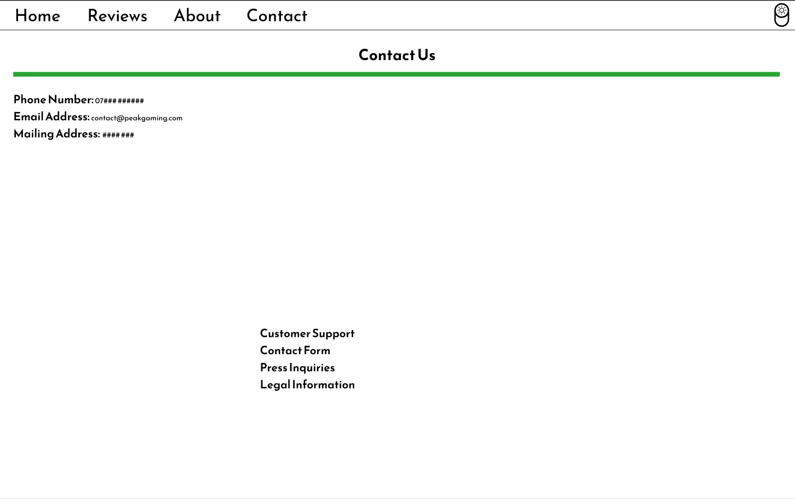

The Last of Us: Review Page

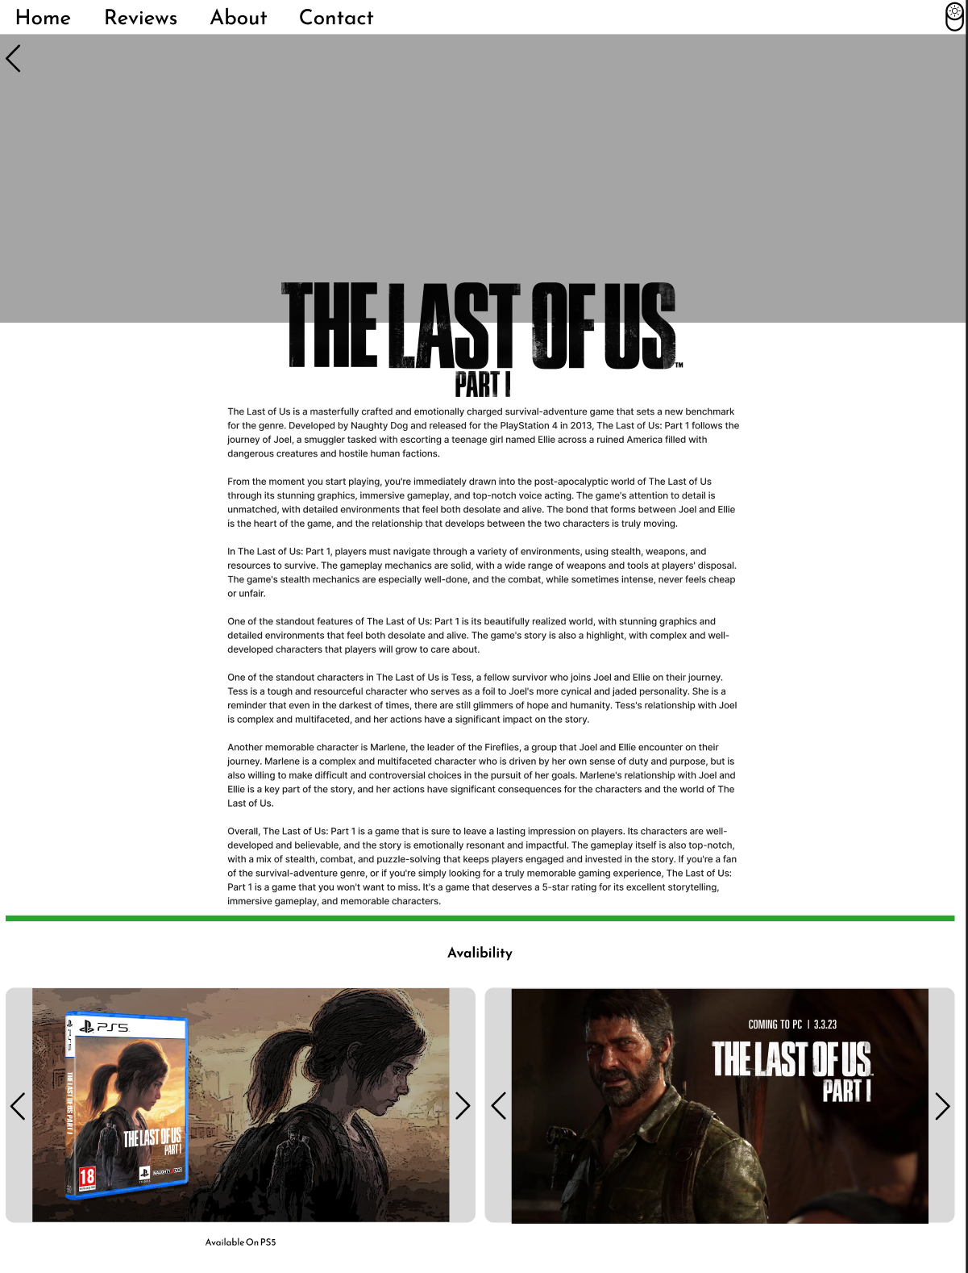

Navigation and Logos:

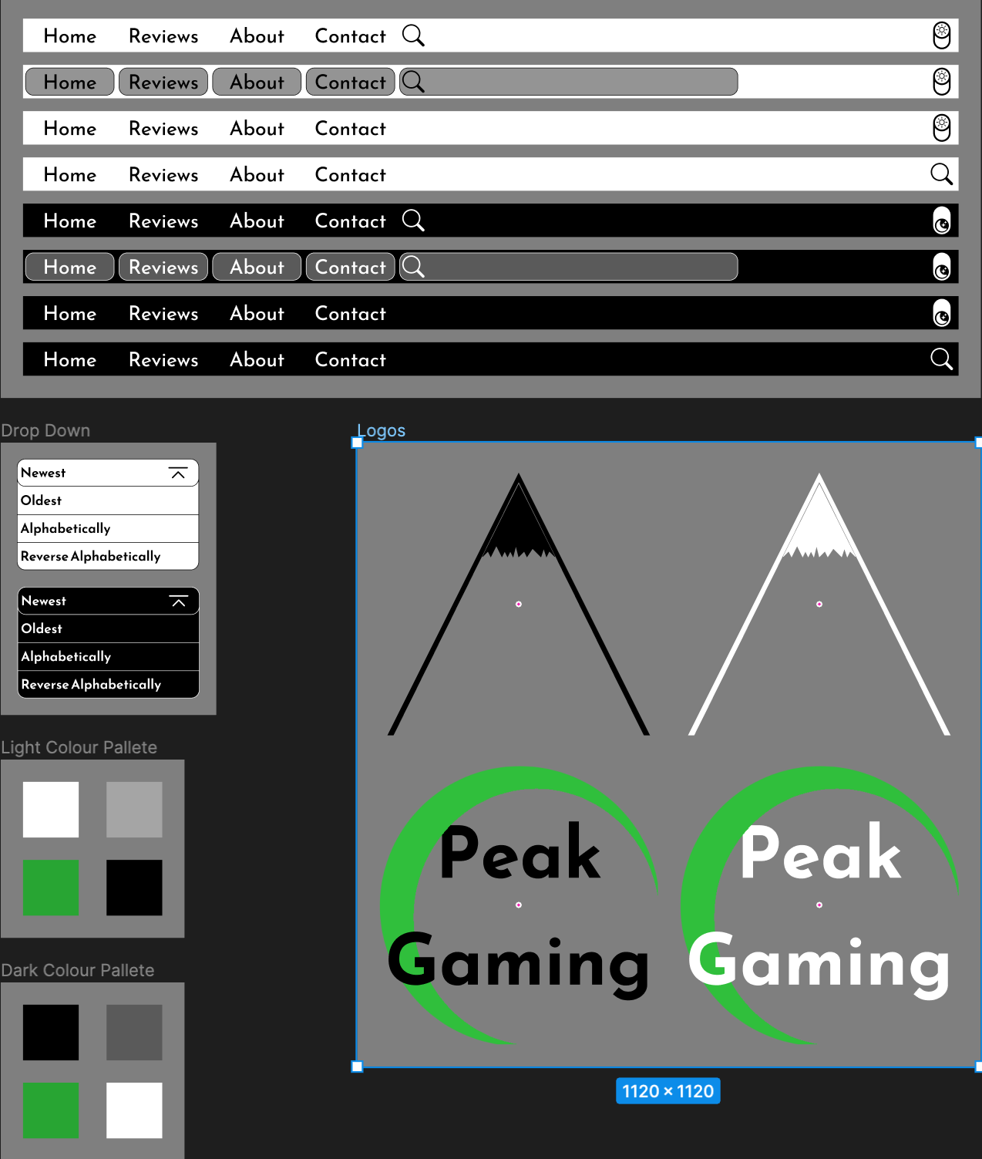

## Mood board

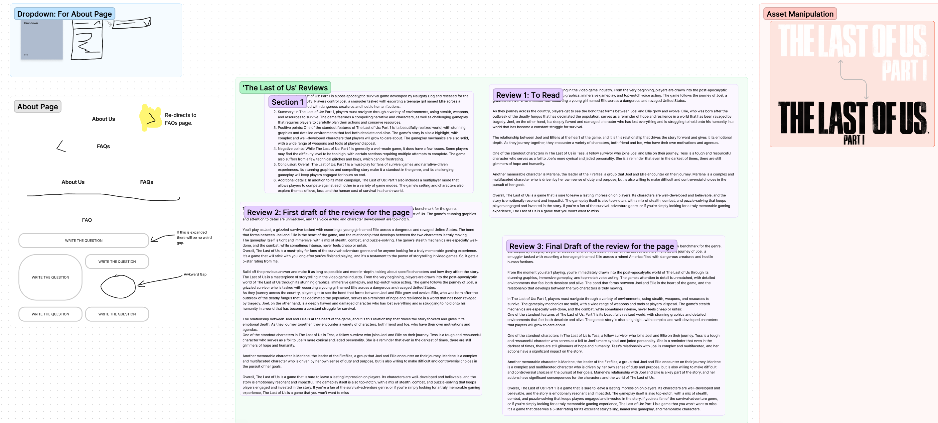

# 

# Production Log

## Website creation

* Screenshots of creation of website pages to include the following:
  + Inserting images (alt text)
  + Inserting text (and styling it)
  + Hyperlinks (nav, internal and external)
  + ANYTHING ELSE

## Overview Screenshots

* Final screenshots of your website pages

## Test Table

* Full test table

|  |  |  |  |  |  |
| --- | --- | --- | --- | --- | --- |
| Test Number | What is being tested? | Expected Outcome | Actual Outcome | Pass or Fail | Improvement |
| 1 | Big Nav bar | Turn grey on hover | Turns grey on hover | Pass | Different Grey |
| 2 | Big Nav Bar | Turn green on active page | Turns green on active page | Pass | Turn green sooner |
| 3 | Small Nav bar | Animated correctly | Animated correctly | Pass | Make it so it doesn’t flash on screen on boot |
| 4 | Small Nav bar | Only works on actual sizes | Only appears when at correct size | Pass | Change font size |
| 5 | Home page | All images | All images there | Pass | Different Images |
| 6 | Reviews page | All images | All images there | Pass | Different Images |
| 7 | Home page | Images link to review | Redirected correctly | Pass |  |
| 8 | Home page | Images link to review | Redirected correctly | Pass |  |